Assignment 1 Web Development II

Git :
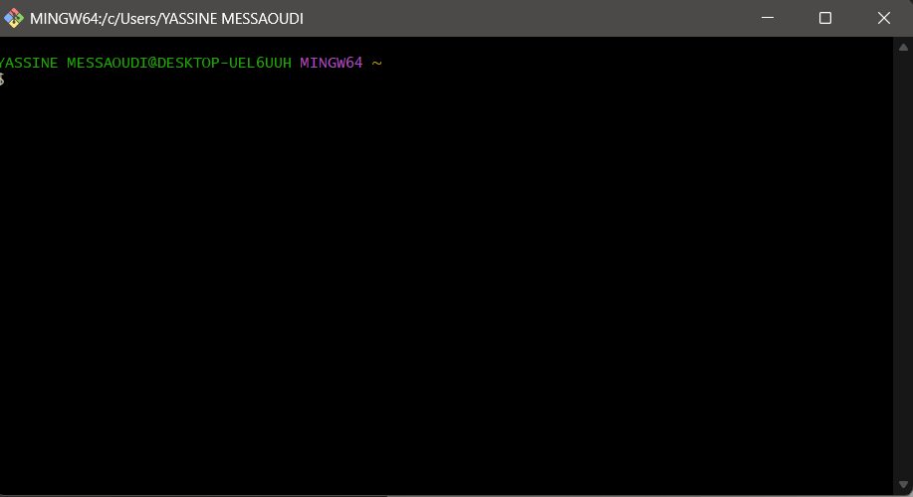
GitHub Desktop :
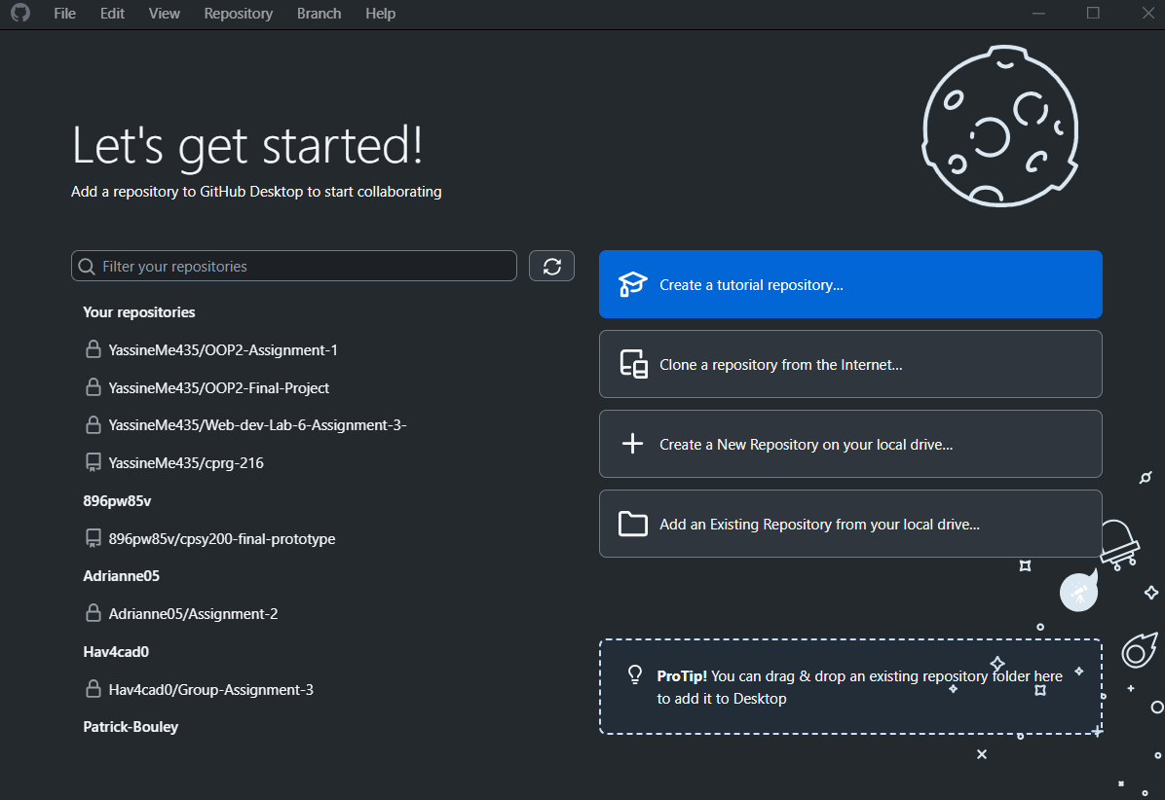
Node.js :
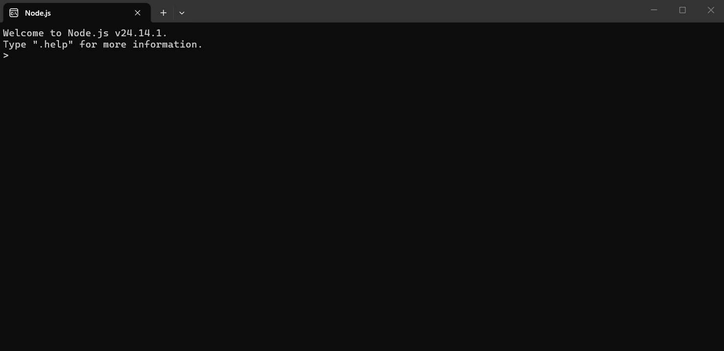
Visual Studio Code :
Github Copilot :
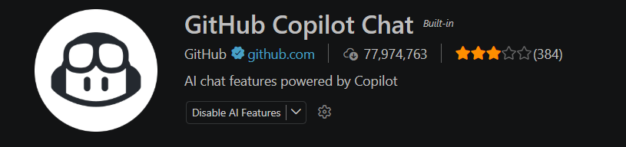
Tailwind CSS Intellisense :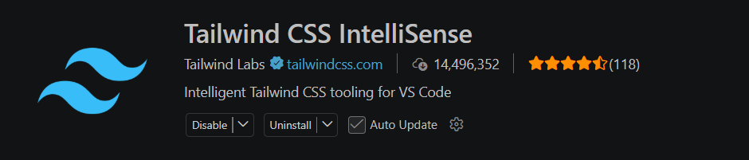
Prettier :
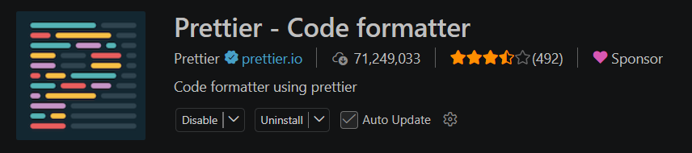
Code Spell Checker :
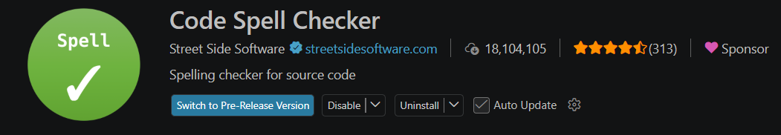
Community events application :
